2021 Unit 3_4 exam: Solns
Question 1
D. The reaction is the formation of biodiesel in a transesterification reaction. The triglyceride reacts with three molecules of alcohol to form one molecule of glycerol and three molecules of biodiesel.

Question 2
C. Most biodiesel is formed from crops such as canola. These crops are harvested annually.

Question 3
D. The equation is C₂H₆ + 3.5O₂ 2CO₂ + 3H₂O 2 mol of ethane will react with 7 mol of oxygen. The volume will be 7 × 24.8 = 174 L

Question 4
A. Stearic acid is a longer molecule than lauric acid. Its longer molecules will have greater dispersion forces between them.

Question 5
B. The question refers to the reverse reaction which is endothermic. Both activation energy and enthalpy are positive.

Question 6
B. The catalyst will increase both the forward and back reactions to the same degree. Therefore B is correct even though it does not go to compare to the back reaction. D is incorrect as the rate of the back reaction is also increased.

Question 7
C. Take note of the very high value of K_{c}. This means the amount of product will be much greater than the amount of reactant.

Question 8
D. If the amount of nitrogen is increased the system will oppose this by favouring the back reaction. This will lower the amount of H₂ and increase the amount of NH₃. The amount of N₂ will end up higher than it was originally.

Question 9
D. Write an expression for K for each and you will see D is correct.

Use the following information to answer questions 10 and 11
The diagram shows a cross section of a zinc, manganese dioxide cell that operates in alkaline conditions.
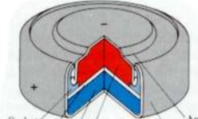
The MnO₂ half equation occurring is
2MnO₂(s) + H₂O(l) + 2e⁻ Mn₂O₃(s) + 2OH⁻(aq)

Question 10
In this cell, the MnO₂
A. is being reduced at the cathode.
B. is reducing zinc ions to zinc atoms.
C. is a catalyst for the reduction of hydrogen atoms.
D. is being oxidised at the anode.

The MnO₂ half equation occurring is
2MnO₂(s) + H₂O(l) + 2e⁻ Mn₂O₃(s) + 2OH⁻(aq)

Question 10
A. The Mn is going from +4 to +3. This is reduction at the cathode.

Question 11
C. The overall equation can be derived by adding the half-equation given to the zinc half-equation Zn Zn²⁺ + 2e⁻

Question 15
C. The products in the aqueous cell will be hydrogen and bromine. Bromine is formed by oxidation so it will be at the anode. The right cell has no water, so magnesium and bromine are the products.

Question 16
A. Q = It = 965 x 100 = 96500 = 1 mol of electrons. 1 mol of electrons will produce ½ mol of magnesium = 12.2 g. Magnesium is only formed in one cell.

Question 17
B. The alcohol group has priority over the alkene so numbering starts on the right hand side. The double bond is on the third carbon.

Question 18
C. This is an ester made from the reaction of an alcohol and a carboxylic acid. Starting at the right hand side, there are two carbon atoms from the ethanol, three carbon atoms from propanoic acid.

Question 19
D. The boiling point of ethanol and ethanoic acid will be higher than the other 2 options as they can form hydrogen bonds. Each ethanoic acid molecule can form 2 hydrogen bonds so it will have the higher melting point.

Question 20
D. The substitution of chlorine atoms can form a variety of products such as tetrachloromethane and trichloromethane. HCl is also formed.

Question 21
B. This is an addition reaction that forms only one product so the atom economy will be 100%.

Question 22
A. The ¹H NMR spectrum is propan-1-ol. It will have four hydrogen environments whereas all of the other molecules will have three.

Question 23
C. Oleic acid shows the presence of a C=C double bond lowers retention time. It is likely that the presence of more double bonds will lower it further. B is not correct as the concentrations of different substances should not be compared and it is the area under the curve, not the height of the curve, that is important.

Section B: Short answer questions

Question 1 (11 marks)
a. Both sugar and wheat are important food stuffs*. They are too important for the community to convert to fuel. It is usually the waste from these plants that is processed for bioethanol. Even if we wanted to make more bioethanol this way there are limitations to the amount of arable land we have*. 2 marks

b. i. wheat: starch 3 marks
ii. sugar cane: sucrose
iii. forest waste: cellulose

c. It is difficult to hydrolyse cellulose to glucose for fermentation. The bonding between cellulose molecules is relatively strong. 1 mark

d. C₆H₁₂O₆(aq) 2C₂H₆O(aq) + 2CO₂(g) 1 mark

e. A 2.00 kg sample of ethanol undergoes complete combustion.
i. Calculate the energy released. 1 mark

______________________________________________________________________________

ii. The volume of CO₂ released at 280 ºC and 120 kPa. 3 marks

_______________________________________________________________________________

_______________________________________________________________________________

Question 2 (12 marks)
a. i. the reaction is endothermic*. An increase in temperature will increase the value of K_{c} and the yield will increase. temperature is increased (Justify your answer)*. 2 marks

ii. the pressure is increased then the reaction moves to the direction with least particles, in this case the back direction, lowering the yield. 2 marks

b. The graph below shows the concentration of ethane gas after a sample is added to an
empty reactor.

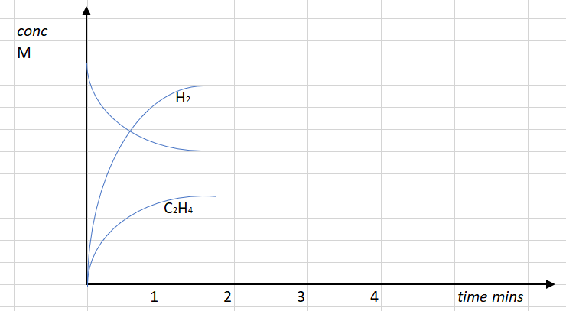

i. see graph 2 marks

ii. see graph below 2 marks

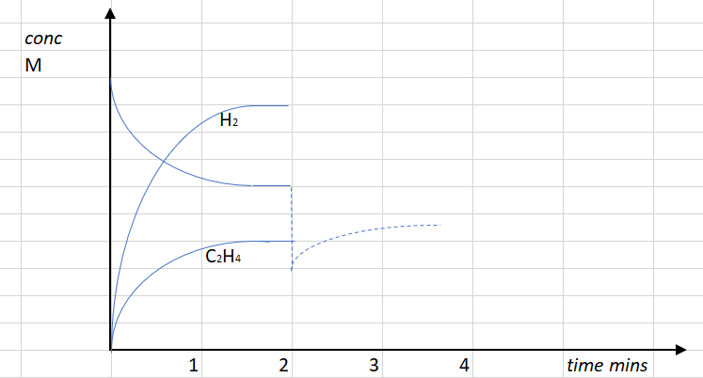 2 marks

iii. The rate will drop*. The decrease in pressure means the particles are further apart and will
not collide as frequently*. 2 marks

c. Hydrogen is a valuable fuel. It could be used to power a fuel cell*. The reaction would be
2H₂(g) + O₂(g) 2H₂O(l)* 2 marks

Question 3 (10 marks)

a. The biodiesel industry* produces glycerol as a by-product of transesterification reactions. When triglycerides are converted to methyl esters, glycerol is formed*.
2 marks

b. Anode: C₃H₈O₃(aq) + 14OH⁻(aq) 3CO(g) + 11H₂O(l) + 14e⁻ 3 marks

Cathode: O₂(g) + 2H₂O(l) + 4e⁻ 4OH⁻(aq)

Overall equation: 2C₃H₈O₃(aq) + 7O₂(g) 6CO₂(g) + 8H₂O(l)

c. The cell produces CO₂ emissions which is not good for the environment.* However, it is a renewable fuel if it is formed from plant oils. It could also take the place of a non-renewable fuel. * It is increasing the usefulness of the biodiesel industry. 3 marks

d. Glycerol will be soluble in water.* It has three polar -OH groups that will form hydrogen bonds with water. *2 marks

Question 4 (8 marks)

a. Anode: 2F⁻(l) F₂(g) + 2e⁻ 3 marks

Cathode: 2H⁺(l) + 2e⁻ H₂(g)

Overall equation: 2H⁺(l) + 2F⁻(l) H₂(g) + F₂(g)

b. Just over 2.87 – 0 = 2.87 volts 1 mark

c. How will the mass of hydrogen gas formed in the cell compare to the mass of fluorine gas?
2 marks

d. Both hydrogen and fluorine are explosive gases. They need to be stored in suitable, secure gas vessels. They also need to be kept separate from each other during formation to prevent their reaction with each other. 2 marks

Question 5 (6 marks)
If you cut a banana into pieces and leave the pieces on the bench, they will gradually turn brown over the next few hours. This is a result of the reaction between the phenols in the banana and oxygen from the air. The phenols react to form polyphenols which are brown in colour. An enzyme called polyphenol oxidase in bananas acts as a catalyst for this reaction.

a. The smaller the pieces, the more surface exposed, the surface area is increased*. The rate of browning will increase*. 2 marks

b. Browning is caused by an enzyme and enzymes are impacted by pH*. The addition of acidic fruit juice is lowering the pH*. Lemon juice is more acidic than the other juices so the level of denaturation of the enzyme is greater*. 3 marks

c. Ascorbic acid is an antioxidant. It can preserve a food by reacting with oxygen in the air. The available oxygen is therefore less. 1 mark

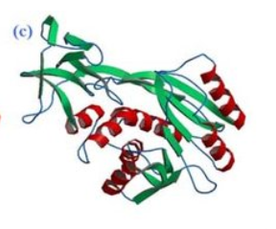
Question 6 (7 marks)
a. 2 marks

β-pleated sheets
coils

The secondary structure is due to the amide
links in the protein chain.
The dipoles on the N and O atoms can lead to
hydrogen bonding between different parts of
the chain.

b. i. cysteine* - S-H and H – S - will form -S -S- a disulfide link*. 2 marks

ii. aspartic acid and lysine* -COOH and H₂N – will form -COO⁻ ⁺H₃N- ionic bond* 2 marks

iii. threonine and serine 1 mark

Question 7 (11 marks)
A sample of an organic compound is tested to try and deduce its structure. It is known to contain carbon, hydrogen and oxygen only. The spectra in this question are provided to help you deduce the identity of the unknown compound.
a. The mass spectrum of the compound is shown below.

i. CH₃CO⁺ 1 mark

ii. several possible answers – two examples below. 2 marks

b. Absence of a broad absorption at or above 3000 cm⁻¹ makes an -OH unlikely.*
Absorption at over 1700 cm⁻¹ likely to be a C=O *
2 marks

c. 4 marks
The ¹³C NMR shows four environments. This rules out any molecules with 3 carbon atoms and means the molecular formula will be C₄H₈O.
The IR rules out a -OH group so it is more likely to be a ketone or aldehyde. The C NMR peak with a shift of 205 suggests a ketone. This makes butanone very likely.
H NMR can be used to confirm this. It will have three hydrogen
environments and they match the –
-triplet
-quartet
-singlet

d. Butanone can be formed from butan-2-ol using Cr₂O₇²⁻ in acid conditions. 2 marks

Question 8 (7 marks)
a. Propan-1-ol and propan-2-ol can both be reacted with Cr₂O₇²⁻ in acid conditions. Propan-1-ol will form propanoic acid and propan-2-ol will form propanone. Propanoic acid would have a much lower pH than propanone.
3 marks

b. Butanoic acid is a weak acid. A pH probe will indicate a pH less than 5 for butanoic acid but not for methyl propanoate. Methyl propanoate should have a fruity odour as well. 2 marks

c. Oleic acid can be cis or trans. The trans isomer packs together more tightly than the cis isomer giving it a higher melting point. 1 mark

d. CH₃CH₂CHOHCl has two optical isomers around the chiral carbon. They will rotate polarised light differently.

Question 9 (10 marks)
A class is investigating different aspects of determining the heat of combustion of peanuts.

One of the students uses the setup shown below, where a peanut is held in a wire holder and burnt under a soft drink can containing 100 g of water. The student is investigating the impact of changing the distance between the flame and the can of water.
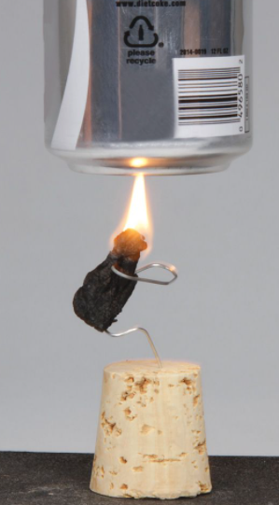
Some of the student’s notes are shown below.
Hypothesis: There will be an optimum distance between the nut and the can.

Experiment | Separation distance (cm) | ∆T
1 | 1.0
2 | 2.0
3 | 3.0
4 | 4.0
5 | 4.0
6 | 4.0
7 | 5.0
8 | 6.0

Experiment 3: Mass of peanut
Final temperature:
Initial temperature

a. - dependent variable: temperature change 2 marks
- independent variable : separation distance

b. The separation distance is the same for these three experiments but T varies. This should not be a surprise as peanuts cannot be assumed to uniform or to be the same mass as each other. The peanuts should be weighed to allow mass to be factored in. 2 marks

c. What conclusion do you think the student could draw from this experiment? 2 marks

d. i. Use the data from experiment 3 to calculate the heat of combustion of a peanut. 2 marks

_______________________________________________________________________________

_______________________________________________________________________________

ii. The documented value for a peanut is 26.5 kJ g. 2 marks
Determine the percentage efficiency of the student apparatus.

_______________________________________________________________________________

_______________________________________________________________________________

Question 10 (9 marks)

a. Methanamine is a polar molecule due to the presence of a nitrogen atom. It should have a relatively high boiling point for a small molecule and it should be soluble in water*. The homologous series of amines should follow a trend – as the molecules get larger the melting point will increase and the solubility decrease.* The impact of the one amine group on the end of the molecule gets less as the molecule gets longer*. If you know a molecule belongs to any homologous series you can expect the same trends of increasing boiling point and decreasing solubility as the molecules get longer*. 4 marks

b. The solution of ethanamine is concentrated so it should be diluted using a volumetric flask and deionised water*.
Prepare a standard solution of strong acid for the titration. *
Select an indicator that changes in the lower pH region.*
Rinse glassware*
Conduct titrations to obtain concordant results.*
Calculate the concentrated of the diluted solution then adjust to the original solution.

5 marks

